Exercise No: 8

Date: 23-11-2020

Aim:

To write a python program to get a sorted list of tuples having first element as the number and second element as the cube of the number.

Program:

n = int(input())

list = []

for i in range(n):

a = int(input())

list.append(a)

r = [(j,pow(j,3))for j in list]

print(r)

def first(n):

return n[0]

r.sort(key=first)

print(r)

Output:

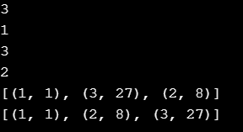

Link:

<http://103.53.53.18/mod/vpl/forms/submissionview.php?id=317&userid=1706>

Result:

Thus the sorted list of tuples having first element as the number and second element as the cube of the number was obtained.